***PAF-Karachi Institute of Economics & Technology***

***(The Center of Excellence)***

***College of Computing and Information Sciences***

***Software Engineering Course Project Task 1***

|  |  |  |  |
| --- | --- | --- | --- |
| ***S.no*** | ***Stud. ID*** | ***Names*** | ***Course Name/CID*** |
| ***1*** | ***9827*** | ***HASSAN NOOR*** | ***SOFTWARE ENGINEERING 106629*** |
| ***2*** | ***9834*** | ***RANA HAMZA ALI*** |
| ***3*** | ***9852*** | ***MUHAMMAD SHEROZ*** |
| ***4*** | ***9879*** | ***AASIR RAFI*** |
| ***5*** | ***10173*** | ***AASHIR MAJEED*** |  |

***Project Title: [SUPER MART MANAGEMENT SYSTEM]***

**Table of Contents**

1. Introduction

2. The General Description

3. Specific Requirements

4. Supporting Information

1. Introduction
   1. Purpose

This document describes the software requirements for the Super mart Management System

* 1. Scope In

This system will be designed to provide the electronic version of Super mart management system. The system will be user-friendly graphical interface and will be more cost effective compared to the current non-electronic systems.

The objectives of this development are:

To provide existing clerks with a new environment in which to make purchase of products.

To provide an avenue for customers to get their products in a more convenient way.

To regain control of the super mart sales to avoid scalping and overselling of products.

To implement a prototype of a scaled down version of the final system to test the solution and further develop requirements.

To collect statistics in a more efficient manner for future super mart development and construction.

1.4 References

Nil

1.5 Overview

It is the brief description of the characteristics of the software to be built, its functions, its users, its constraints and its dependencies

1. The General Description:
   1. Product Perspective

The Super mart Management System diagram showing the overview of the system’s module and the relationship of the systems to external interfaces is presented here

Figure 2.1 Overview/ Architecture diagram of the SMS



SMS

Customer

Admin

Serververe

Database

Interface

Terminalinale

PC

Cell Phonee



Business Logic

Function of System Component:

Database:

* Stores data
* Creates reports
* Provides access to data
* Update information
* Delete unnecessary information

Server:

* Provides access to database
* Authentication users
* Perform backups
* Produce reports

External Interface:

Terminal:

Users use terminals to access the server

Customer and operator use terminals to purchase the products and to get information about the available stock.

Super mart administration may use terminals to see the reports generated by the database software.

Personal Computers

Users (customer, operator, and hotel administration) may use personal computers to obtain a remote access to the server and the database via the Internet.

Computer Hardware and Peripheral Equipment to be used:

Work stations, which include CPUs, monitors, keyboards, and mice

Printers

Network

Terminals

Cell phones to test connection to the server via remote access

* 1. Product Formation

This section provides summary of the functions that the software will perform

* + 1. Function Relationship
* Figure 2.2 to 2.6 depict the relationships among the functions to be implemented by the system.  
    
  Figure 2.2 SMS General Function Relationship/**Higher Level Use case** Diagram

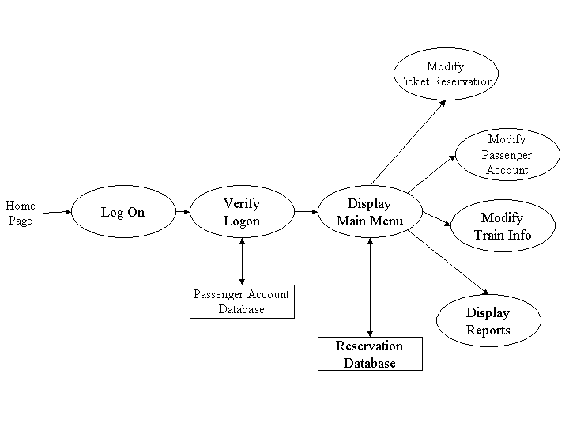

Module 1

Module 2

Module 3

Module 4

2.2.2 Function Description:

2.2.2.1 Log In function:

Description:

This function ensures that only authorized users gain access to the databases. An authorized user is a user who has an account on the system. Users include customer, super mart officials and operators. The user must type a valid username and password to gain access

2.2.2.2 Module 2

Description:

# Client Side UI is Different.

# Module Admin Panel UI is different

# If any new Product to our data base Web Dom will be updated automatically.

# If any customer want to delete item on a cart it’s applicable

# Product search Render

2.2.2.3 Module 3

Description:

We will create a new database.

We will create tables.

We build relation between tables.

All the data will be reviewed

Data can be updated using queries

Data can be updated using queries

Data can be searched by using queries

2.2.2.4 Module 4

**Description:**

Employee can send email related to the booking.

Employee generate the bill.

Here logics are build Here we will apply GUI

Employee can review the details of payment GUI work reviewed here. Employee can operate payment table once the payment done

Employee can delete the credit of the client after payment

Employee can search the unpaid bills.

2.2.2.5 Module 5

Description:

Admin can login into the project and can enter new operators

Admin can review all the activities done by the operator and client and all the payment information’s and order product.

Admin can update all the

Admin can delete all the

Admin can search the customer record in the project

# 2.2.2.6 Module 6

Business logic create for order and item from view to model with the help of controller business logic Business logic review for all order and item from view to model with the help of controller business logic

Business logic update for all order and item from view to model with the help of controller logic

Business logic delete for selected order and item from view to model with the help of controller logic

Search a specific order and item from view to model with the help of controller logic.

**2.3 User Characteristics**

The main users of the system will be the customer purchasing products , the operator that process sales for customers, and the administration that access the reports generated by the system. The users are not required to have knowledge in the computer field. The graphical interface provides an easy way of using.

**2.4 User Characteristics**

The constraints for the project are:

* Only those users which enter correct username and password can only be entered.

**2.5 Assumptions and Dependencies** **or Business Logic**

The assumptions for the project are:

The customer add products of their choice in the cart.

They can choose unlimited products.

If any product is out of stock customer cannot buy it.

After all the purchase of products customer have the choice to delete any of it.

After the confirmation, all the products code will be scan and a bill will be created.

Customer can pay bill by cash or by entering bank accounts details.

**3. Specific Requirements**

This section of the SRS contains design requirements

**3.1 Functional Requirements**

**3.1.1 Module 1 complete Log in Function**

1. Description: This function ensures that only authorized users gain access to the purchase databases. An authorized user is a user who has an account on the system. Users include customer, hotel officials. The user must type a valid username and password to gain access.
2. ***Usage Scenario/ Use case Description/******Specification:***

|  |  |
| --- | --- |
| Description | Allows access to online SMS |
| Inputs | Username, password |
| Source | User inputs username and passwordPress Login Button |
| Alternate case |  |
| Outputs | Successful login; unsuccessful login |
| Destination | Dashboard |
| Precondition | Authorized User |
| Post Condition | No change to Customer Accounts Database |
| Side Effects | Failures and successful logins are sent to Database |

# Module 2 complete CRUD Customer Side

# 

# Description:

# This function ensures that only authorized users gain access to the booked databases. An authorized user is a user who has an account on the system. Users include customer, Super Mart official’s .The user must type a valid username and password to get access.

***(b)Use case Diagram as an ADMIN SIDE***

Use case diagram is used to organize, identify and clarify the system requirement. It consist of the interaction between the system and user.

User can be called as an actor. In this diagram actor is an employee who logged in into the system. After validation of his identity he will be moved on to the home page of the system in which he can access all the objects in the system and can add , edit and delete from the system

# 

**Use case Diagram as Customer Side**

In this use case diagram of the customer side the customer is an actor who can see the products available and add the products which he wants to buy into a cart and proceed to the confirmation of order. Then the customer will proceed to the payment method in which he can pay the bill offline and online as well. When the payment will confirmed then the customer will leave the system.

# 

# Use case Realization:

Admin:

**Model**:

User (Employees), Category, Stock, Sales, Product, Stores, Suppliers, Orders, Category, Price, Job.

**View**: Dash Board, Render Body Area.

**Controller:** Registration, Login, Add, Edit, Delete Methods.

**Customer:**

**Model:** Product**,** select product, order product, confirm product

**Controller**: Registration, Login, Phone, address, name, payment method.

**View:**  Dash Board, generation bill, supplies order date.

# Flow of event or Data Flow Diagram:

# 

*ADMIN SIDE:*

In this diagram admin is logging in into the management system. There has to be an admin validation which check the admin is valid or not. Then the admin will able to see the home page of management system and will able to see the tables and can also add delete and update from the tables. Admin can logout.

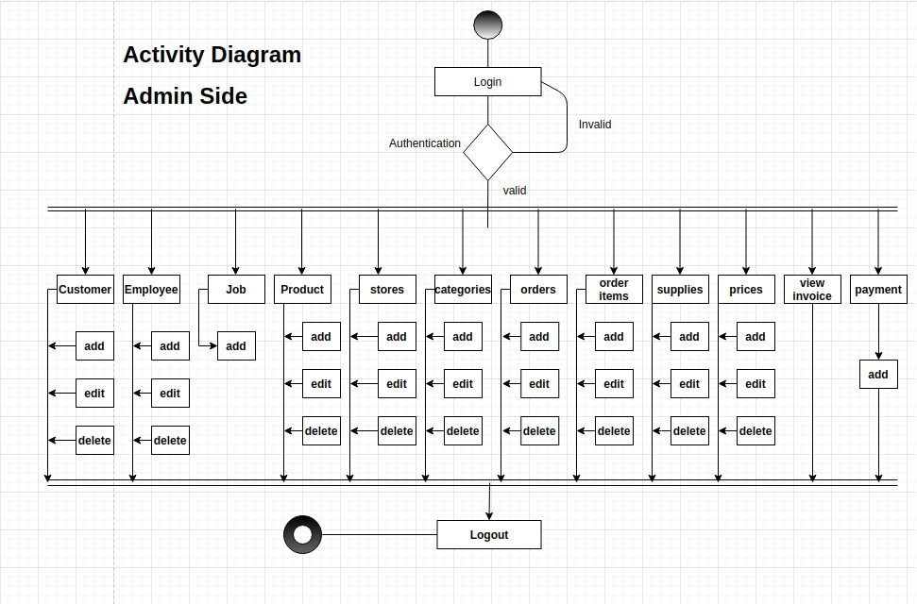

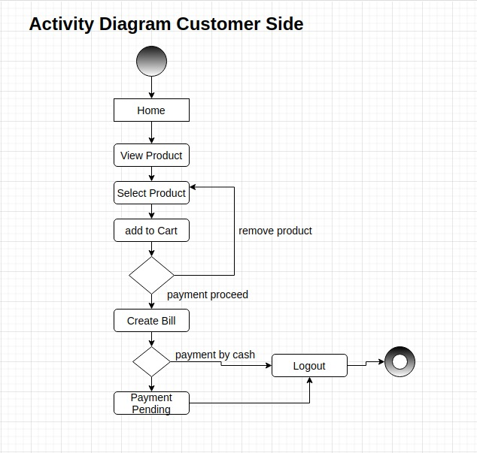

# Sequence Diagram

# ADMIN SIDE:

# It is showing that how the server is communicating with the admin and other tables. In this diagram it is also showing the timing for communicating the message from one object to another.

# 

*CUSTOMER SIDE:*

In this diagram the customer is communicating with the server for buying the products from the mart.

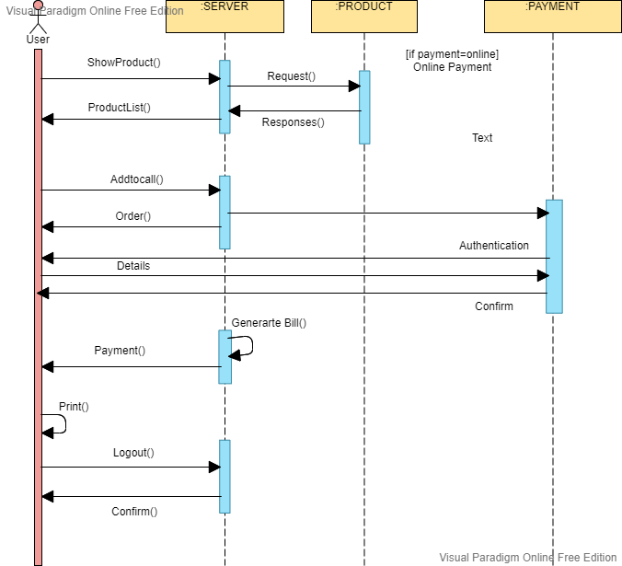

# Collaboration Diagram

# *ADMIN SIDE:*

# In collaboration diagram also known as communication diagram shows the interaction with each other. In this diagram it is showing the interaction of the admin with server and other object.

# 

*CUSTOMER SIDE:*

In collaboration diagram of customer side shows the interaction between customer and other object of a system. Customer interact to a server of buying products from the mart.

# 

# Activity Diagram

# ADMIN SIDE:

In this diagram admin is logging in into the management system. There has to be an admin validation which check the admin is valid or not. Then the admin will able to see the home page of management system and will able to see the tables and can also add delete and update from the tables. Admin can logout.

# 

*CUSTOMER SIDE:*

On customer side, customer will see the home page and can add the product they want to buy from the mart and add to cart. There is a decision box which will decide if the customer wants to proceed to the payment or want to remove any of the products. Then the customer will proceed to the payment method. When the customer complete shopping the bill creating process will start in which there will be another decision box which will ask if the payment is online or by cash.



# Class Diagram

# State Chart Diagram

# ADMIN SIDE:

# In this diagram admin will log in and move to the state of home page after putting username and password. There will be a validation process. Admin can move to any state of show, edit or delete from any table.

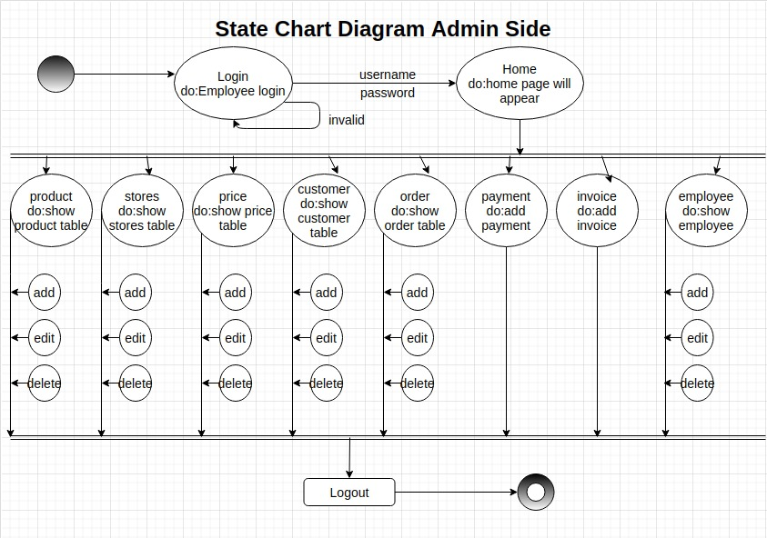

# CUSTOMER SIDE:

In customer state chart diagram customer can buy the product after visiting certain states

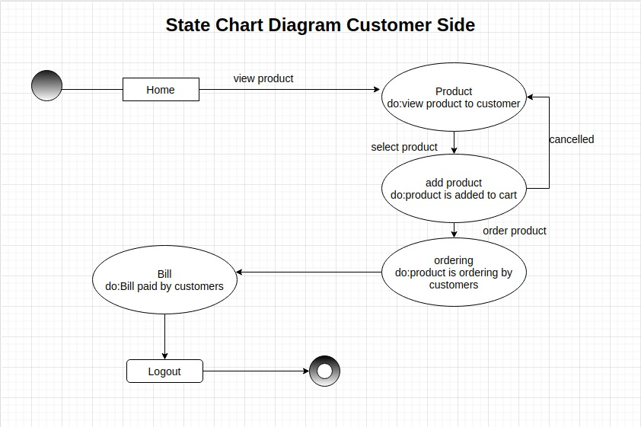

* + 1. **Module 3 complete CRUD Admin Side**

1. ***Description:*** 
   * 1. **Module 4 complete CRUD Business Logic**

1. ***Description:***

Business logic can be implement in the sense of invoices here we can manage all the things about our customer invoices that are generated at the end of shopping.

* + After going to invoices that show in our dash board here we can easily check the records of our invoices.
  + Admin/Employee can click on any option that display
  + If the employees click on the invoices.

System will show all the records of invoices includes the

Information about the customer. Which invoice belongs to which customer and which employee create this invoice.

* Admin/employees can also view and also change the setting about creation of invoices and calculation that are done.
  + 1. **Module 5 complete CRUD Database**

Dashboard has all the database records about all the tables

There are 7 tables

**Product:**

It contain all the information about what type of product available and what type of product not available in our Mart and it is also contain about the information of prices of items that available.

Admin can do 3 functions

1. Create
2. Delete
3. Edit

**Prices:**

It contain the information about the prices of all things that available in our stores and here we also update the prices and also delete the old prices and also add new prices of different item that comes in our store.

Admin can do 3 functions

1. Create
2. Delete
3. Edit

**STORES:**

It contain the information about stores that are interlink with our Mart. Sometimes different thing that not available in our store that the customer want in that type of situation we arrange this specific thing with different store that available with our link. Here we also perform Crude operation.

Admin can do 3 functions

1. Create
2. Delete
3. Edit

**Customers:**

It contain the information about our customer that visited in our Mart.

Here we also check the information about the customer that who was visited in our mart and also see record about5 his/her purchasing.

Admin can do 3 functions

1. Create
2. Delete
3. Edit

**Employees:**

It contains the information about our employees that working in our Mart and also hold the information of each employee like phone no, address, living area, Date of joining also about the experience about self, and also its password that is help to login in our Mart.

Admin can do 3 functions

1. Create
2. Delete
3. Edit

**Order:**

It contain information about order that placed by our customer and also here we can also saw that which order in pending and which order is delivered to our customer.

Admin can do 3 functions

1. Create
2. Delete
3. Edit

**Invoices**:

It contain all information about all the invoices that are create in our management. Here you can also see all the created invoice of different person for the check and balance

Admin can do 3 functions

1. Create
2. Delete
3. Edit
   1. **External Interface Requirements**

**3.2.1 User Interface**

**LOGIN VIEW:**

# E:\5th Semester\OOAD\login.PNG

HOME PAGE:

This homepage will appear after log in.

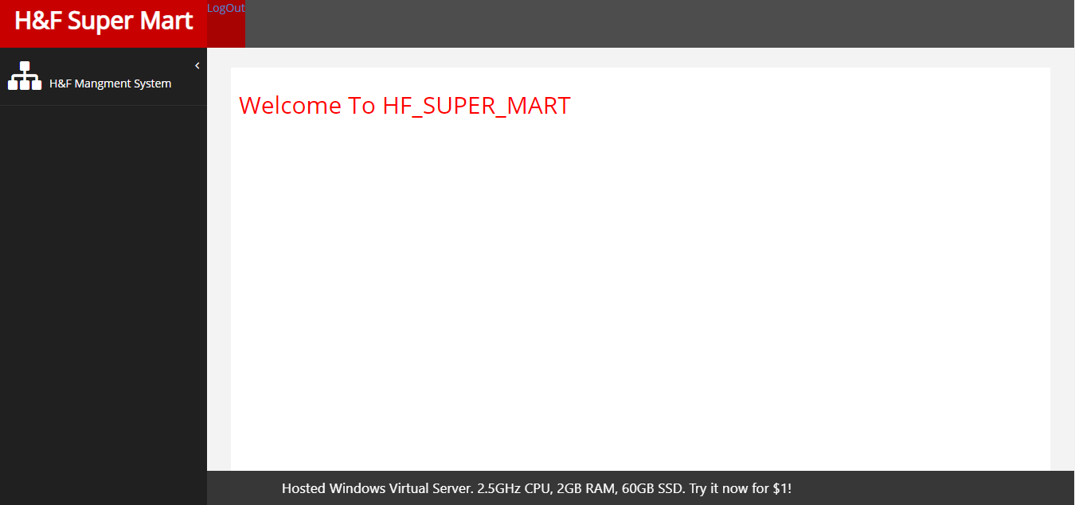

EMPLOYEE TABLE:

You can add employee who can login into the system.

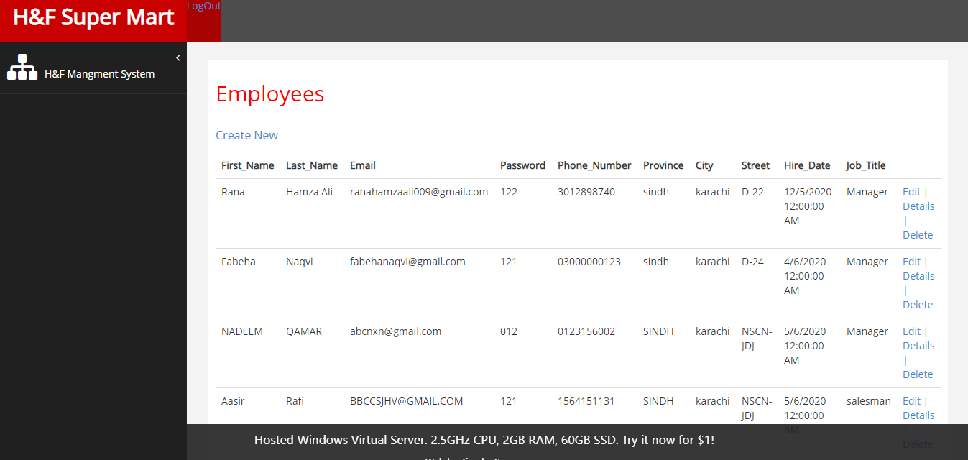

ORDER TABLE:

Order details shows here which can be edit and delete.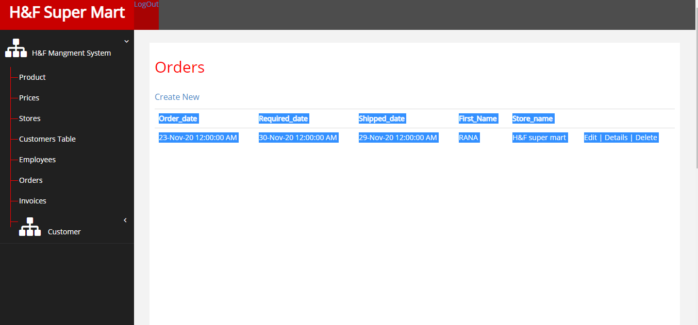

PRODUCT TABLE:

It is the product table in which employee can edit and delete products.

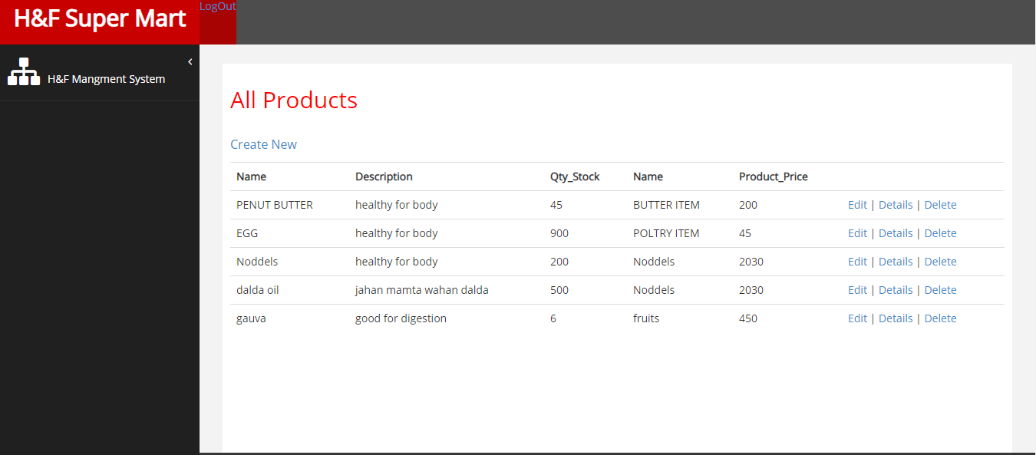

**TRANSECTION FORM**

ADD:

Admin can also add a product into a table.

# E:\5th Semester\OOAD\add product.PNG

EDIT:

Admin can also edit any product in the system.

# E:\5th Semester\OOAD\edit.PNG

DELETE:

Admin can also delete the product from the system.

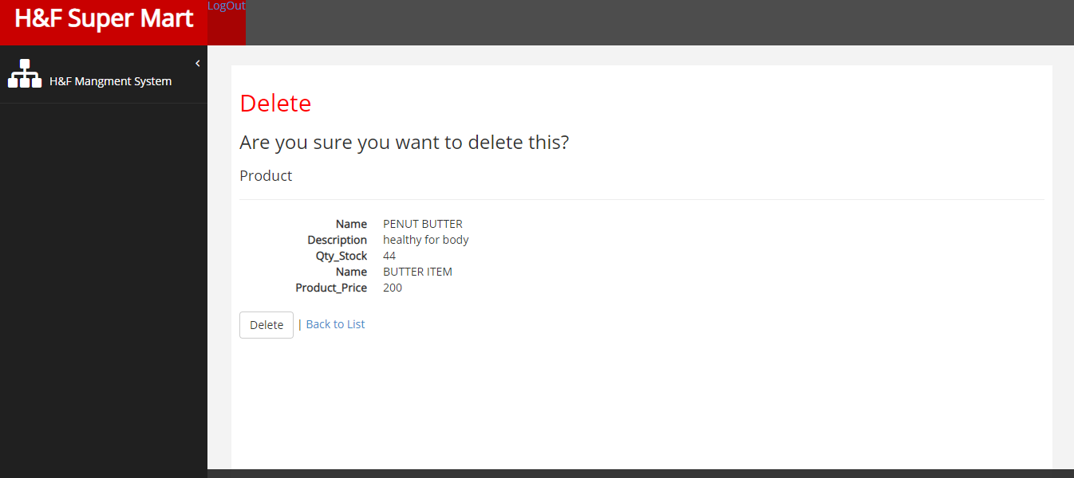

# INVOICE :

# Here you can see all the created invoice of different person for the check and balance.

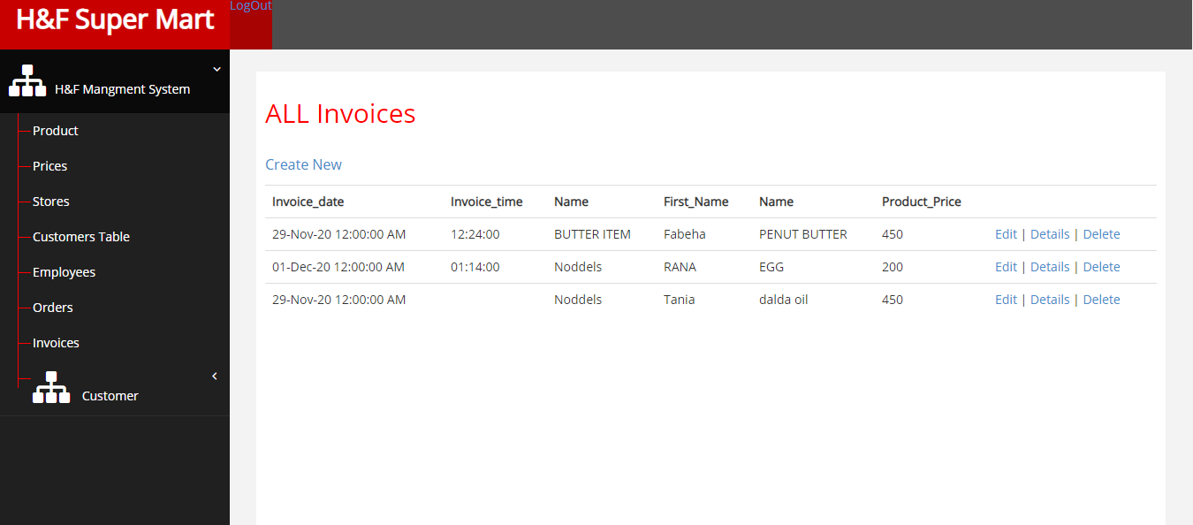

# CUSTOMER VIEW:

# Here you can easily see that about the customer who was visited to our SMS system.

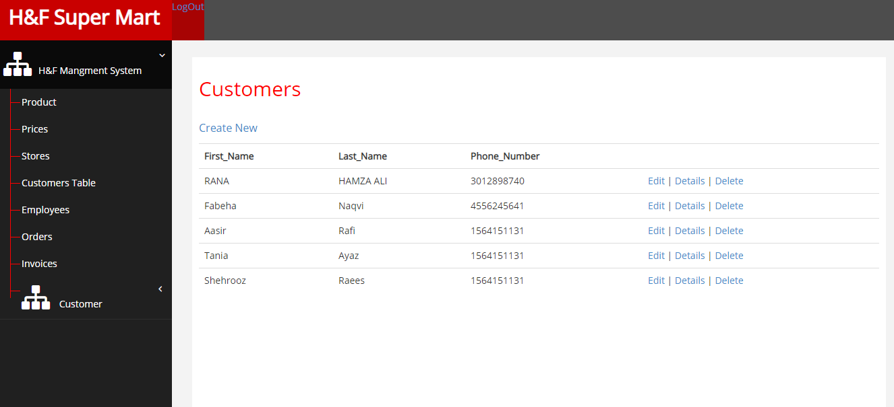

**3.2.2 Hardware Interface**

The SMS includes two major hardware components: cellular phones and regular PC's. The cell phones require WAP (wireless application protocol) network protocol, which is already programmed in the latest phones.

The second component involves the regular PC’s, which communicate with the server. The server then communicates with the database. The protocol involved between the PC's and the server is the HTTP protocol, which allows communication between the PC's and the Server. The remote PC's, such as someone accessing the SMS from home using the Internet, are able access the information through the CGI. The requests come in through the HTTP protocol, and using an ODBC the database results are returned and processed using Perl to give an HTML web page. The format of the output is displayed as web pages.

**3.2.3 Software Interface**

* + - Visual Studio 2015
    - Google Chrome
    - SQL Server Management
  1. **Performance Requirements**

**3.3.3 Host Requirements**

|  |  |
| --- | --- |
|  | Type of Host or  Equipment |
| Host A | PC |
| Host B | Database Server |
| Host C | Application Server |
|  |  |

* 1. **Standard Compliance**

There are no design constraints that can be imposed by other standards limitations.

**3.4.2 Software Limitations**

•        must be able to run Internet Explorer or browsers to access the system.

•        must have cell-phone web based capability to access the system from a mobile phone.

**3.4.3 Hardware Limitations**

•        Input/Output: One or two-button mouse, keyboard, cell-phone, or touch screen required.

•        Network card required at thin-client terminals to make communication with server possible.

* 1. **Quality Characteristics**

There are a number of quality characteristics that apply to the SMS software system.

**3.5.1 Portability**

The SMS system will be developed using HTML and Java so that it can be accessed from any type of system using just a regular web browser. It will also be available to users that have web access on their cellular phones. The system will be tested on all types of hardware before being released to ensure that is it compliant with this requirement.

**3.5.2 Reliability**

The system should be capable of processing a given number of product purchased within a given time frame with no errors and the system should be available and operational all the time.

**3.5.3 Usability**

The SMS system will be developed so that it is an easy to use system that requires the least amount of user input possible. Every input will be validated. The user should only have general computer use knowledge. Error messages will be displayed if the user enters an invalid value or tries to access a function without the required permissions. An easy and well-structured user manual will be provided to the SMS and the system will include descriptive help for all operations allowed.

**3.5.4 Flexibility**

The SMS system should be developed in such a way that it is easily customizable. If new functions are required by admin, there will be little effort required to update the system to support new cities or new transactions.

**3.5.6 Security**

The SMS system should not compromise the customer information at any time. The user information will never be sold to other parties and will be kept secure at all times. Users will be authenticated to ensure that no unauthorized users gain access to private information.

**3.5.7 Maintainability**

The SMS source code will be kept well structure and documented so that it is easier to maintain and extend the system. All changes to the system shall be documented.

**3.6.2 Operations**

The normal operations required by the user can be viewed as the following:

User-initiated Operations:

These operations include the login operation, which is initiated by the users. Also, the process of becoming a new user is in this category. Building, changing, and viewing itineraries, as well as paying for the itinerary are all initiated by the users. The user initiates the report generation activity.

Interactive Operations and Unattended Operations:

The users initiate all the operations mentioned above, and almost all of them are somehow interactive... The report display is a non-interactive operation, although selecting the desired reports will require user input.

Data Processing Support Functions:

The user account data is used to create new accounts, as well as to validate user ids during login functions. For building itineraries, user input, user account data, processed. User data along with final results of user interaction (whether the user purchased a room, number of people, etc.) are collected, and used for report generation purposes. Administrative users' inputs are collected in order to modify and present schedules.

Backup and Recovery Operations:

Both databases used (customer account database and reservations database) are production databases.

**3.6.3 Site Adaptation Rééquipements**

There are no site adaptation requirements for this project.

**4. Supporting Information.**

There is no supporting information required for this project.